**Class 3 Assignment**

**Name:** Matan Reuven Tal

**1.**

kubectl run superset --image=amancevice/superset

kubectl get pods

kubectl describe pod/superset

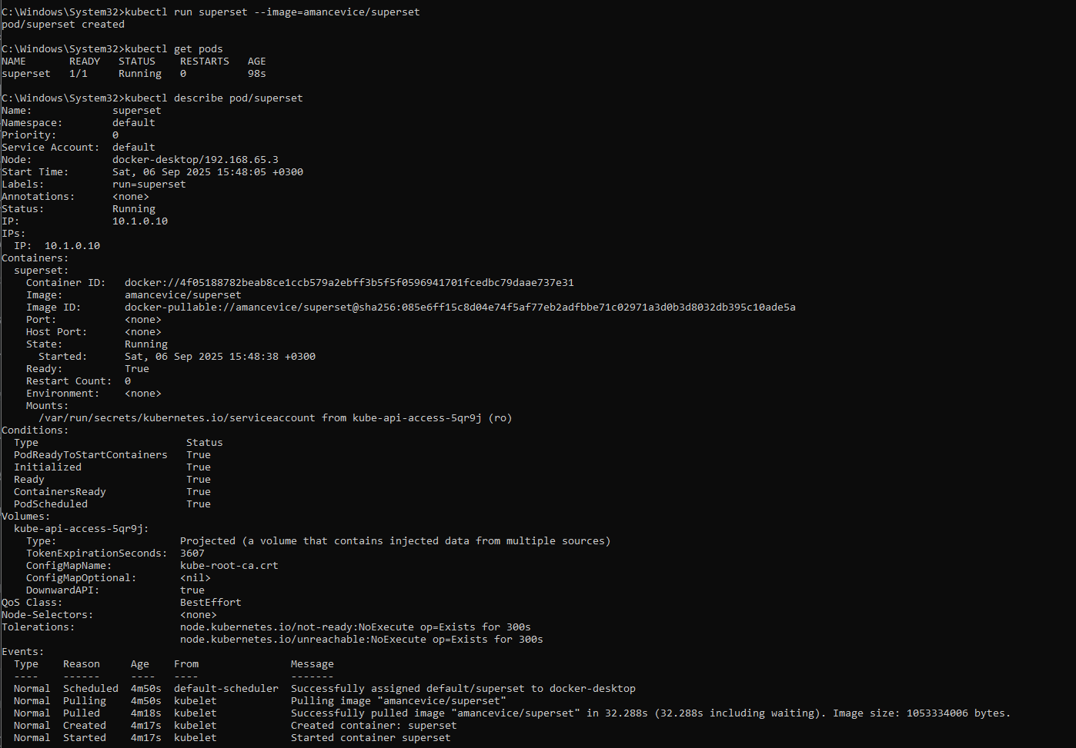

**2.**

kubectl expose pod/superset --port 8088 --type NodePort



**3.**

kubectl apply -f superset-app.yaml



**4.**

kubectl run airflow --image=puckel/docker-airflow  
kubectl expose pod/airflow --port 8080 --type NodePort



**Bonus:**

**1.**

apply -f superset-full-stack.yaml

minikube service superset-service

apply -f airflow-full-stack.yaml

minikube service airflow-webserver-service

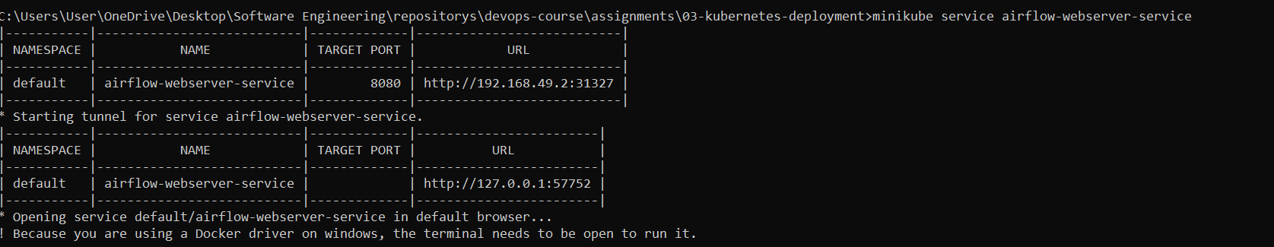

**2.**

kubectl apply -f airflow-app.yaml

kubectl describe pod airflow

